SRN:PES1UG21CS182

NAME:DILIP H

SEC:C

Github link: <https://github.com/dilipharish/Cinemas_Rating>

MVC LAB:

1. A)I used Cinemas.java to initialize the data Models and CinemasDto.java to access, update the Data Models.

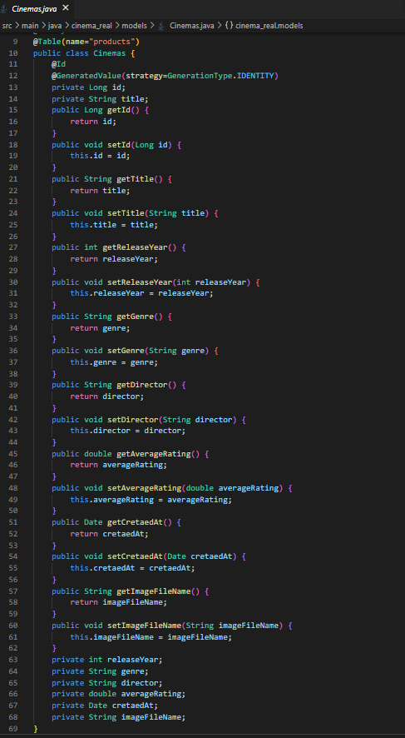

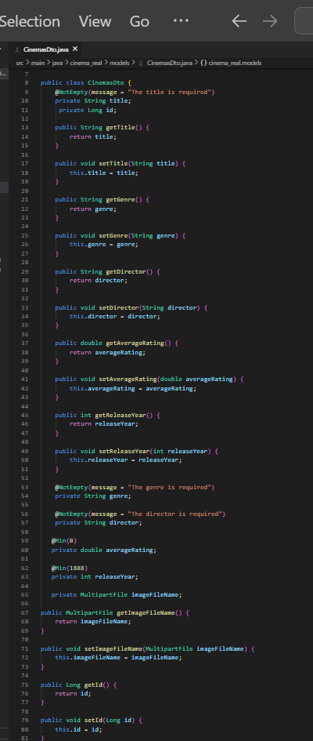

B)Controller logic : GetMapping,PostMapping Used to do respective works

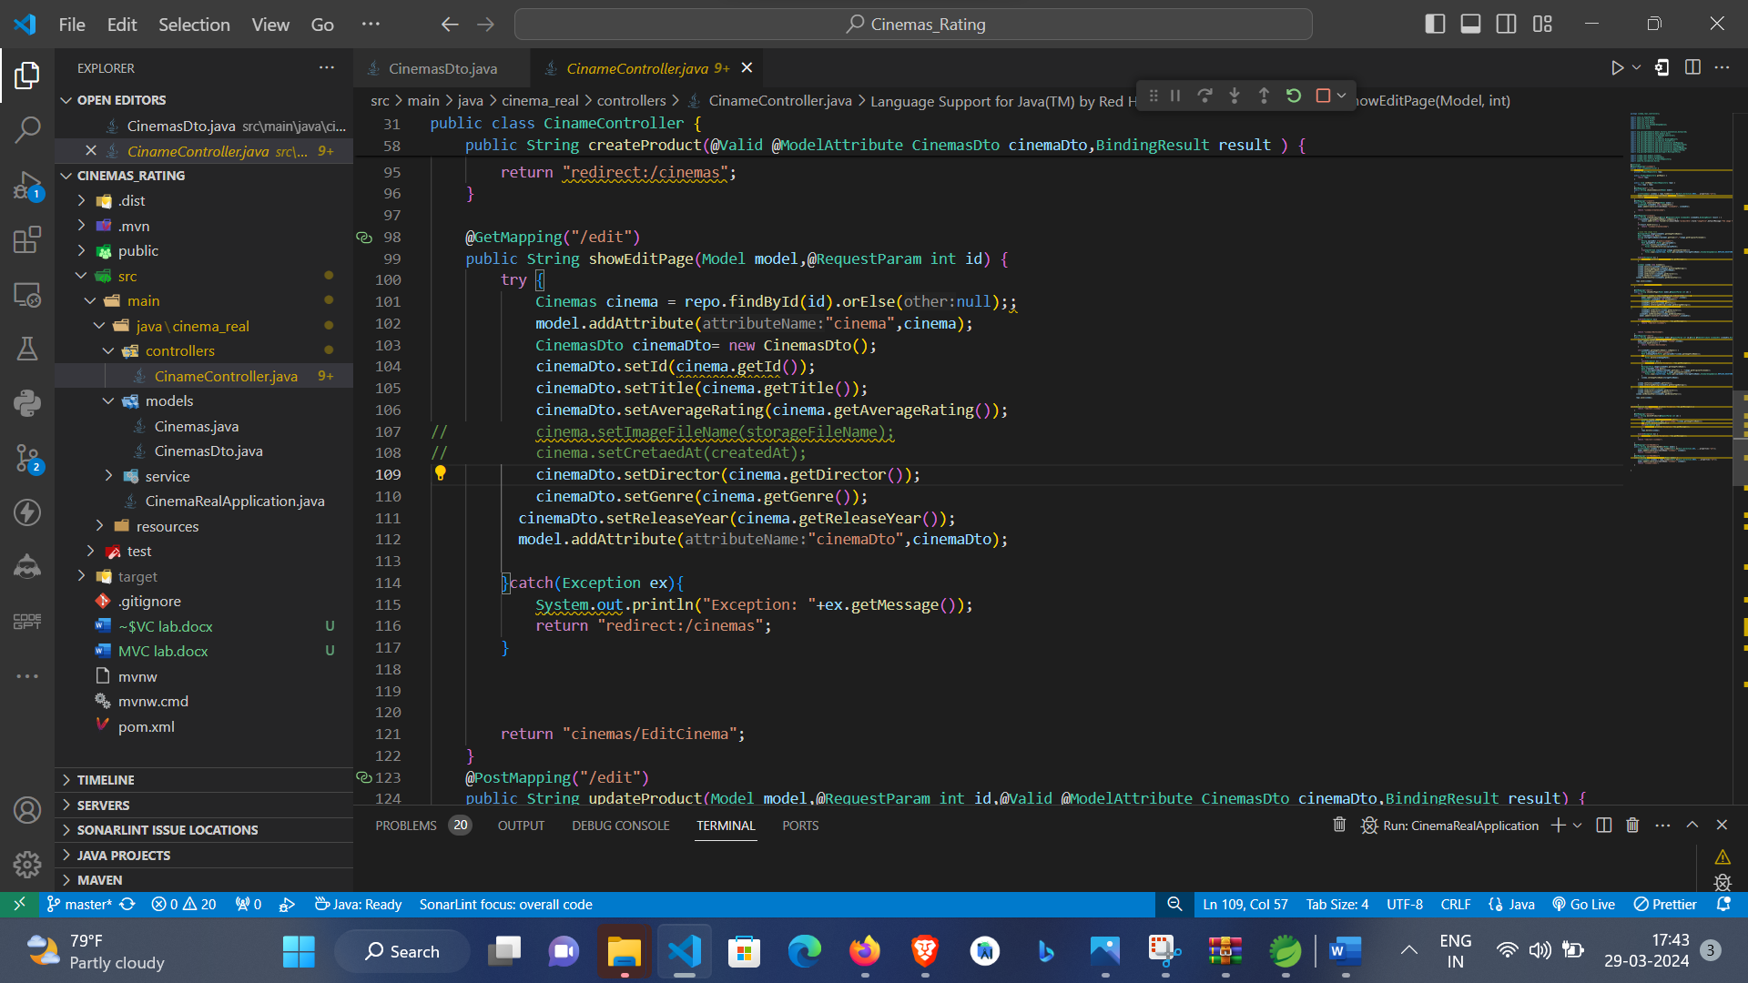

C)View : Basic Html is Used to Implemented to View the UI

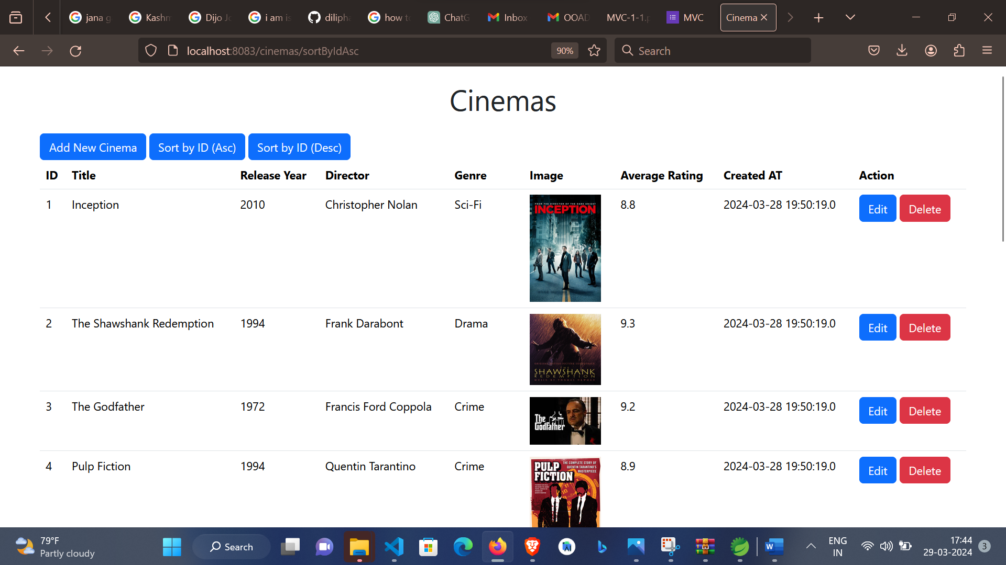

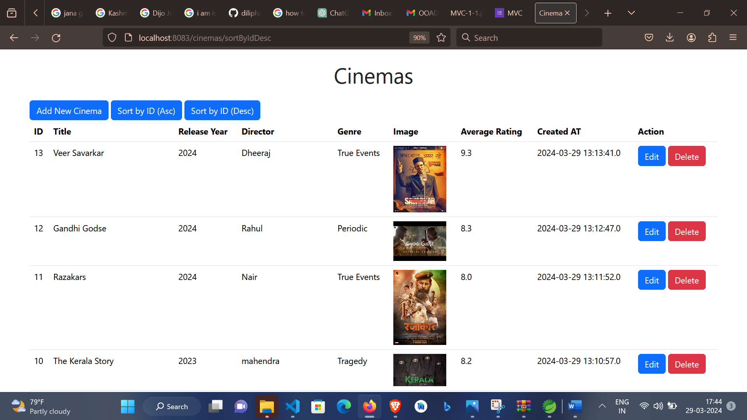

2)Code Written by me:

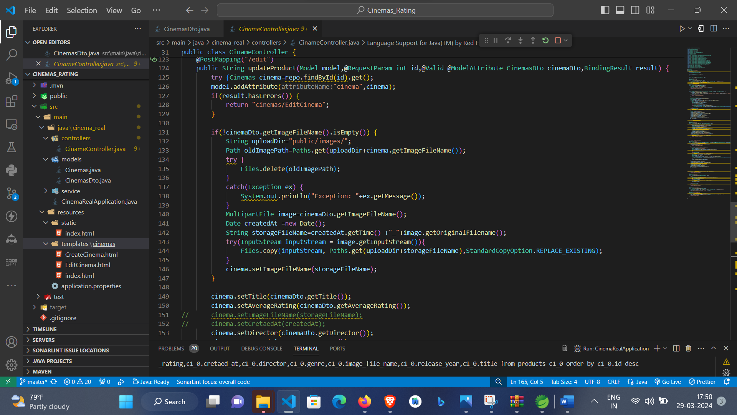

3) Screenshot of console with application running



4) Screenshot of UIs related to the two scenarios with values, outputs, errors

Adding New Movie’s Rating:

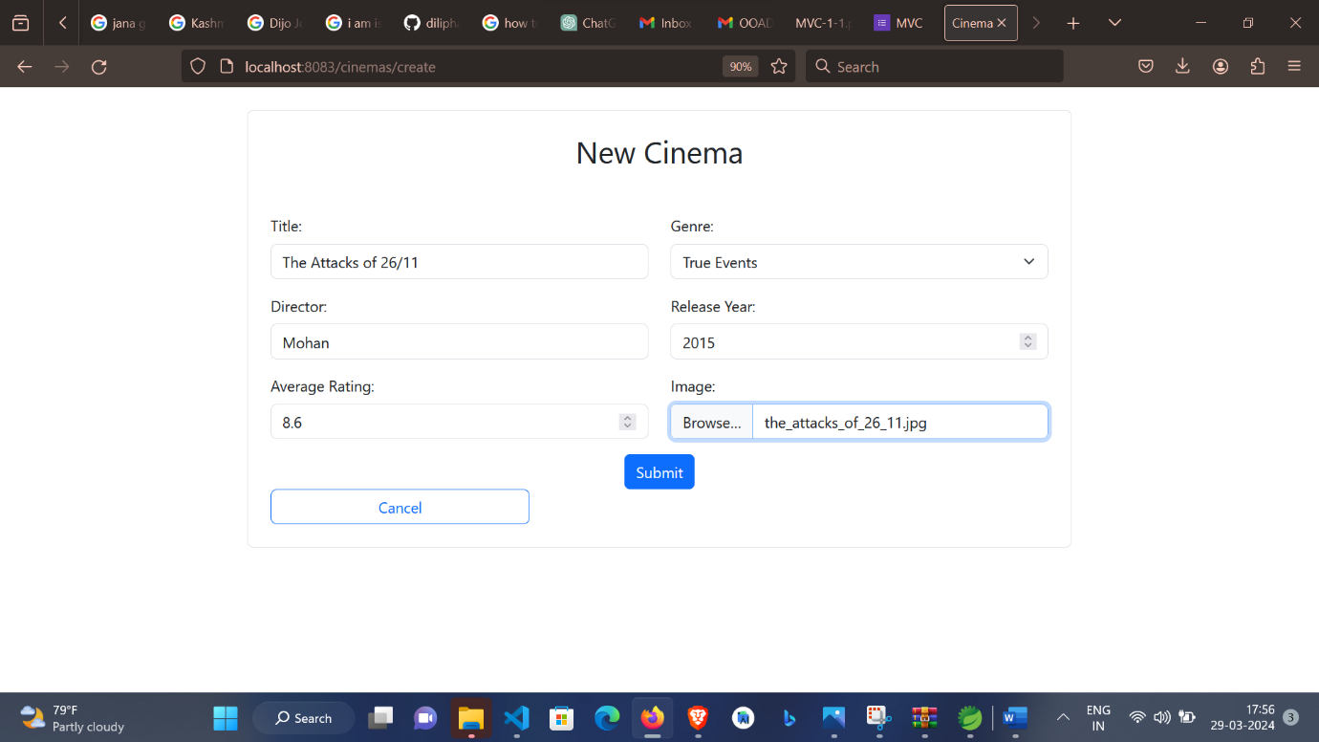

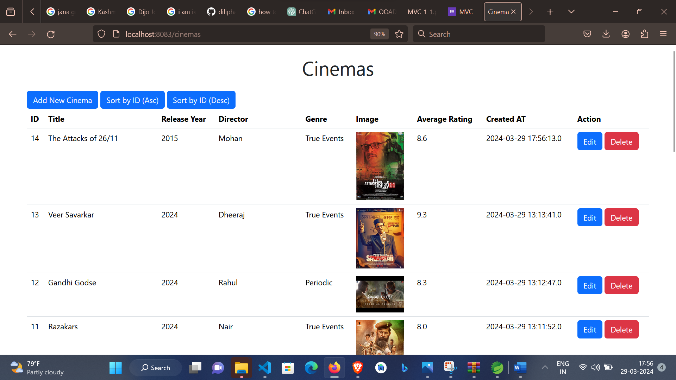

Editing The Movie Ratings:

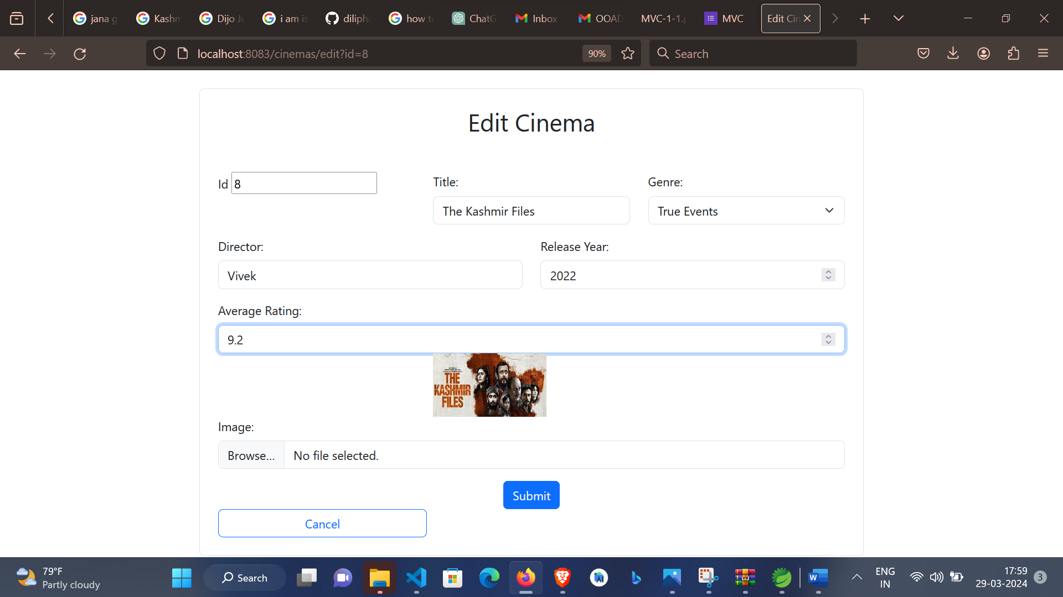

5) Screenshot of database with data items

